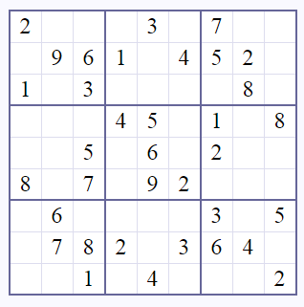

Code 1:

A=

B=

C=

C

B

A

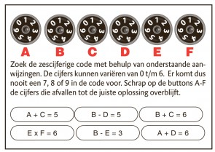

Code 2:

A= B= C= D= E= F=

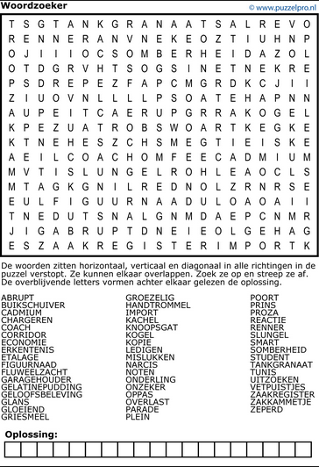

Code 3 = oplossing