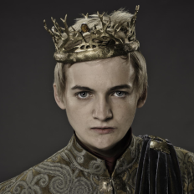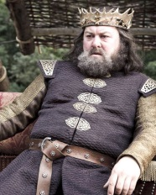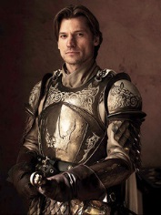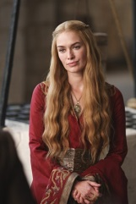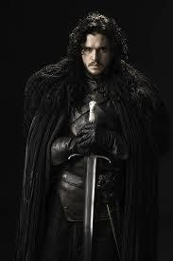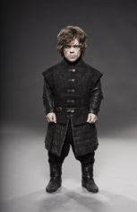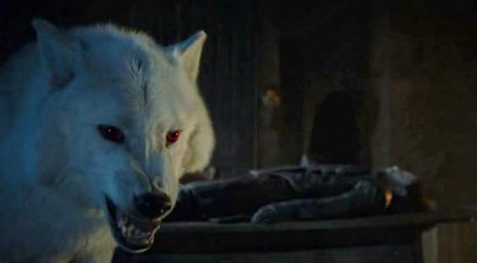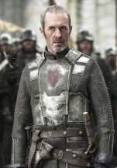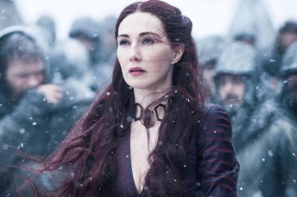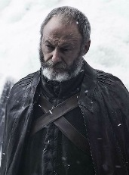

**Tyrion Lannister**

**The mountain**

**Jaime Lannister**

**Cersei Lannister**

**Tywin lannister**

**Arya stark**

**Robb stark**

**Jon snow**

**gosth**

**Ned stark**

**Joffrey Baratheon**

**The Red lady**

**Davos Seaworth**

**Stannis Baratheon**

**Robbert Baratheon**

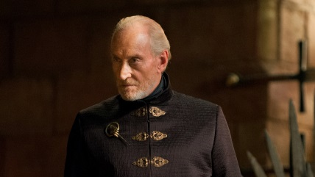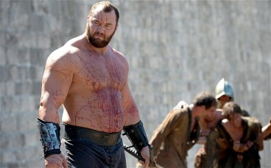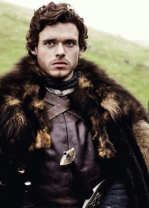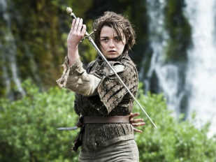

0

0

0

I

II

III

IV

I

II

III

IV

I

II

III

IV

**Tyrion Lannister**

**The mountain**

**Jaime Lannister**

**Cersei Lannister**

**Tywin lannister**

**Arya stark**

**Robb stark**

**Jon snow**

**gosth**

**Ned stark**

**Joffrey Baratheon**

**The Red lady**

**Davos Seaworth**

**Stannis Baratheon**

**Robbert Baratheon**